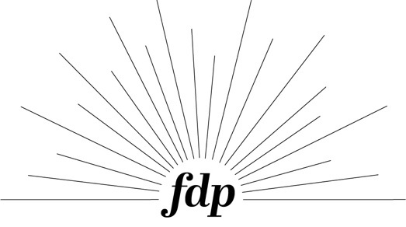
Name:
Date:
Total cost:
Deposit paid:
Estimated Completion:

Dinner Plate // 11 in diameter // $40

Lunch Plate // 9 in diameter // $35

Pasta Bowl // 9 in X 1.5 in // 20 fluid ounces // $40

Soup Bowl // 5 in x 3 in // 22 fluid ounces // $30

Mini Bowl // 3.5 in x 2.5 in // 10 fluid ounces // $15

Mug // 3.5 in x 3.5 in // 16 fluid ounces // $26

Cup // 2.5 in x 6 in // 24 fluid ounces // $24

The Complete set includes:

- Dinner Plate

- Lunch Plate

- Pasta Bowl

- Soup Bowl

- Mini Bowl

Discounted to $150 per 1 serving
The Basics set includes:

- Dinner Plate

- Lunch Plate

- Soup Bowl

Discounted to $100 per 1 serving

The Custom set includes:

- Mix & match any of your favorites!

Price calculated at cost for each item based on selection

Step 2 : pick your quantity

- Minimum of 4

- Even numbers only

Step 1 : pick your set

- The Complete set

- The Basics set

- Custom set

Step 3 : pick your color(s)

- Colonial white

- Eggshell

- Sedona

- Mustard

- Clear

Step 4 : pick your style

- Traditional

// think rustic and homey with long edges and a perfect stack

- Modern

// clean lines with short vertical walls, simple design that is timeless

